Lab: JUnit Testing in JCreator

**Part 1: Setting up JUnit Testing in JCreator**

Unit testing isolates a segment of code from an application or software and tests this module to determine if it is fit for use.  Unit testing can be done in Java programming using the JUnit testing framework.

This guide goes through the process of setting up and using JUnit with the JCreator IDE.

After launching JCreator, a new project should be created, or an existing project should be opened.  To create a new project, click on *File* from the toolbar menu, and select the *New* menu option.  Click on the *Project* option from the resulting sub menu.

[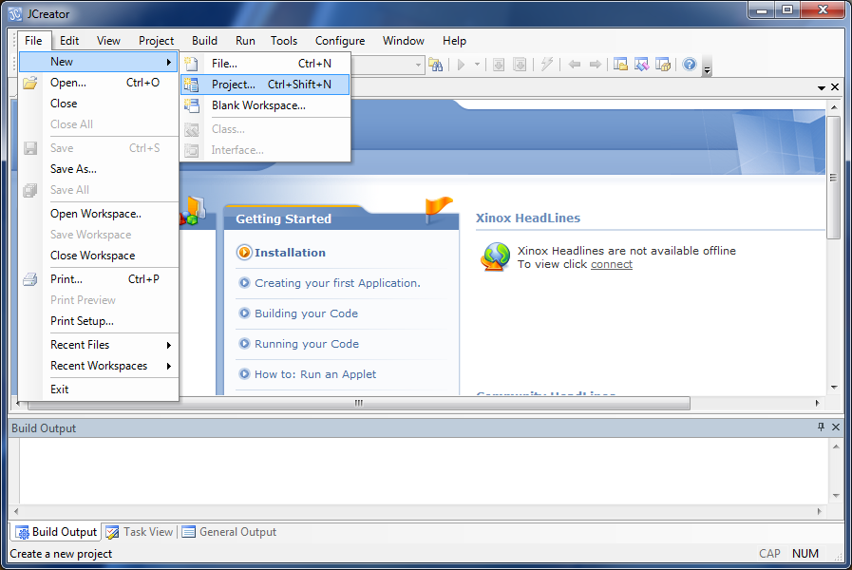](http://oopbook.com/wp-content/uploads/2013/02/jcreator-junit-1.png)

The *Project Wiz*ard will be launched to help you create your JCreator project.  Select *Basic Java Application* from the list of options, and then click on the *Next* button to proceed.

[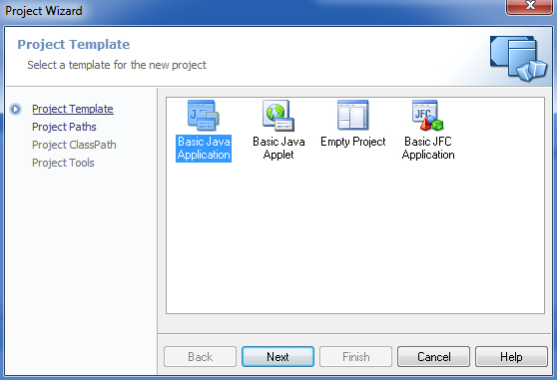](http://oopbook.com/wp-content/uploads/2013/02/jcreator-junit-2.png)

In the *Project Paths* settings, give the project a name in the *Name* field of the form, and then specify the *Location* of the workspace to be created.  The *Source Path* and *Output Path* locations will be automatically added when you change the *Location*. After all settings have been specified, click the *Next* button.

[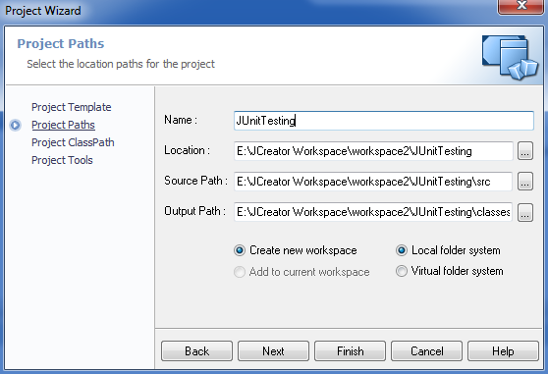](http://oopbook.com/wp-content/uploads/2013/02/jcreator-junit-3.png)

In the *Project ClassPath* settings, ensure that the correct JDK version is selected in the *JDK Profiles* tab.  Select the *Required Libraries* tab, located at the top of the wizard.

In the *Required Libraries* tab, click on the *New* button then select the *Add Archive* from the drop down options.

[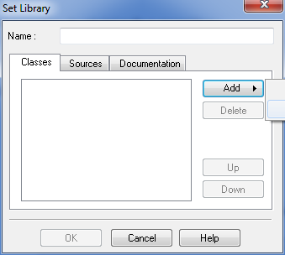](http://oopbook.com/wp-content/uploads/2013/02/jcreator-junit-5.png)

Browse to the location of the JUnit JAR file that you may have previously downloaded. In this tutorial, you will be using JUnit version 4.10. **There is a copy on the x: drive** or You can download JUnit 4.10 here:

[JUnit 4.10](http://oopbook.com/wp-content/plugins/download-monitor/download.php?id=19)

After selecting the JUnit JAR file, enter a name for the library in the Name field.  The name “*JUnit 4.10*” was used in this tutorial, which is a good naming convention, since JCreator remembers the libraries used.  Finally, click on the *OK* button to close the *Set Library* window.

[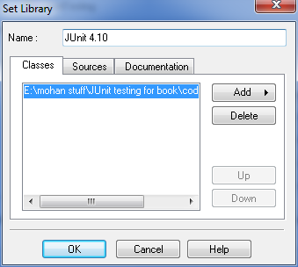](http://oopbook.com/wp-content/uploads/2013/02/jcreator-junit-7.png)

In the previous window, ensure that the checkbox next to the newly added JUnit library is selected.  Next, click on the *OK* button.

[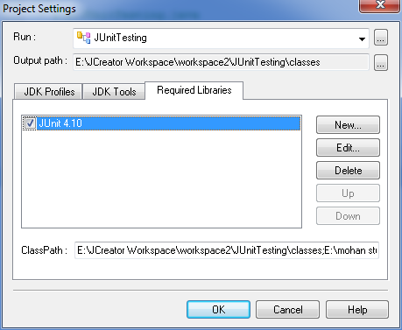](http://oopbook.com/wp-content/uploads/2013/02/jcreator-junit-8.png)

Finally, click on the *Finish* button of the wizard to complete the creation of the JCreator project workspace with the added JUnit testing library.

In the *Required Libraries* tab, click on the *New* button then select the *Add Archive* from the drop down options.

Browse to the location of the **hamcrest-core-1.3.RC2** file that you may have previously downloaded.  **There is a copy on the x: drive** or You can download hamcrest-core-1.3.RC2 here:

http://search.maven.org/#search|gav|1|g:%22org.hamcrest%22%20AND%20a:%22hamcrest-core%22

After selecting the hamcrest-core-1.3.RC2, enter a name for the library in the Name field.  The name “*Hamcrest*” was used in this tutorial, which is a good naming convention, since JCreator remembers the libraries used.  Finally, click on the *OK* button to close the *Set Library* window.

In the previous window, ensure that the checkbox next to the newly added hamcrest-core-1.3.RC2 library is selected.  Next, click on the *OK* button.

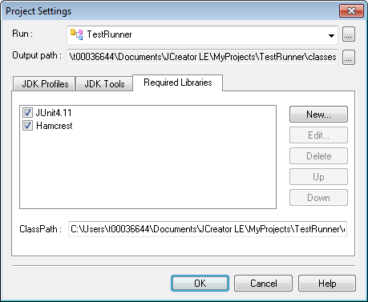

Finally, click on the *Finish* button of the wizard to complete the creation of the JCreator project workspace with the added JUnit testing library.

**Part 2: Writing the JUnit Test**

Three java files will be required to perform JUnit testing in Jcreator:

1. The file you want to test: example Student on the x: drive
2. The test suite file: example StudentTest on the x: drive
3. The file to run the test: TestRunner

First you will need to delete any unwanted files…

In the newly created project, delete any unwanted files that were generated by JCreator by right clicking on the item in the *File View* panel on the left, and then selecting the *Delete* option.

You can now create new files in the project or add existing files to the project.  To add existing files, right click on the project name on the File View panel, and select the *Add* option.  Click on the *Add Existing Files* option from the resulting menu options.

[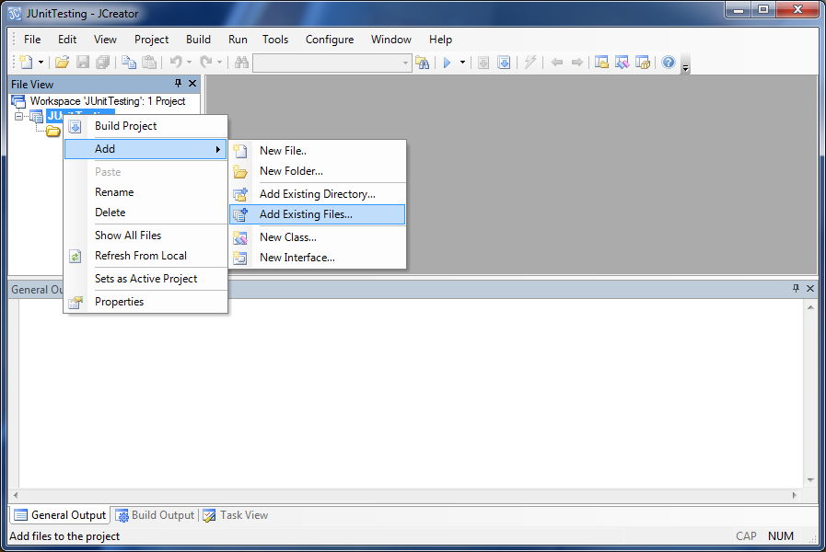](http://oopbook.com/wp-content/uploads/2013/02/jcreator-junit-10.png)

A file browser window will appear, allowing you to add one or more files to the project.  JCreator will ask you if you would like to copy the file to the project, or open the file as an external file.  As a rule of thumb it is better to copy the file to the project by clicking on the *Add* button.  By opening a file as an external file, you run the risk of affecting the project, if the external file is moved, edited or deleted.

[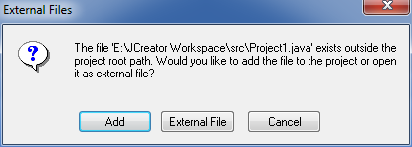](http://oopbook.com/wp-content/uploads/2013/02/jcreator-junit-11.png)

You should add the three required files from the x: drive (Student.java,StudentTest.java and TestRunner.java). You will find these files in the JUnit folder.

To execute the test suite within the JCreator environment and to view the results on the JCreator output panel, you will need to manually write a class to run the test suite. You can copy the TestRunner.java file from the x: drive. **You may need to change the name of the test suite file in the** TestRunner **file.**

The *TestRunner* class provides a base for executing the test suite and viewing the results of the JUnit tests.

You can copy the TestRunner.java file from the x: drive

or

You can download TestRunner.java from here:

[TestRunner](http://oopbook.com/wp-content/plugins/download-monitor/download.php?id=18)

After writing/modifying the test runner file, the project should be built. This can be done by clicking on the Build option from the toolbar menu, then selecting the Build Project menu option.

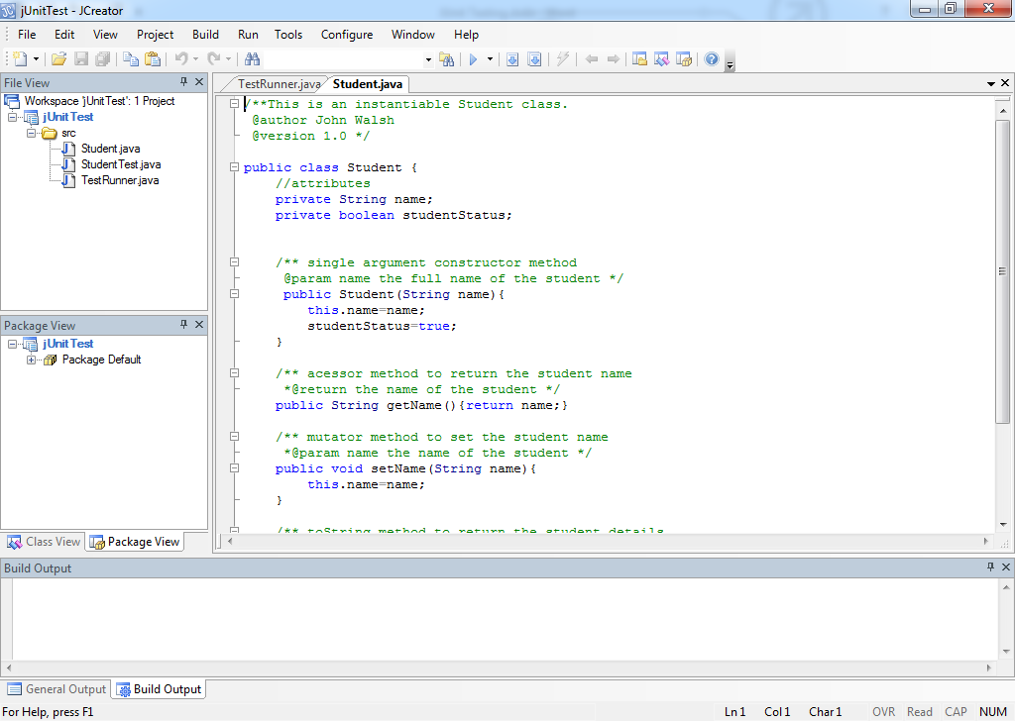

If there are no errors and the build has completed successfully, you can now open the test runner file by double clicking on it in the *File View* panel on the left.  Next, click on the *Run* option from the top toolbar, and select the *Run File* option to execute the test runner class.

You should see the results of the JUnit test suite in the *Build Output* window panel at the bottom of JCreator.

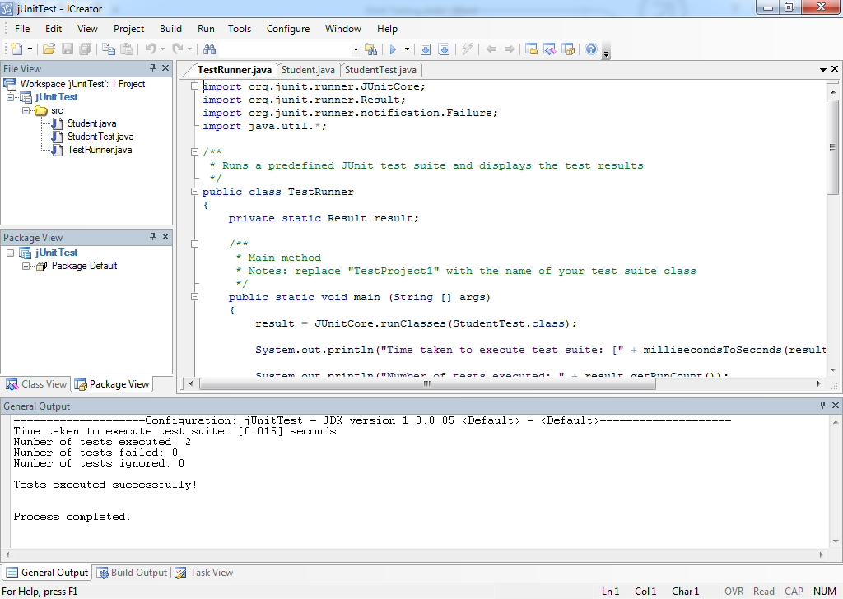

**Source:** [**http://oopbook.com/junit-testing/junit-testing-in-jcreator/**](http://oopbook.com/junit-testing/junit-testing-in-jcreator/)

**Modified by J Walsh**

Exercise1 : Write a class with a multiply method. Write and appropriate test method for the multiply class. Run your test.

Exercise2 : Add additional methods and tests to the Student and StudnetTest files.